Comparison Between Dual Core And Quad Core :

1. **Dual Core :** a) A dual core processor has two cpu cores on a single chip.

b) Dual core processor can execute two tasks simultaneously,which can lead to improve performance compare to single core processor.

1. **Quad Core :**  a) A quad core processor contains four cpu cores on a single chip.

b) Quad core processor can handle four tasks simultaneously,which can significantly boost

performance for multitasking and demanding applications compare to dual core processor.

Comparison Between Intel I5 And Intel I7:

1. **Intel I5 :** a) It usually comes with 6 cores and 12 thread in the recent generation.

b) Typically has a smaller cache.(E.g.- 9 MB L3 cache)

c) Generally has a lower TDP,making it more power-efficent.

d) More budget friendy,providing a good balance of performance and cost. It is suitable

for general computing, office applications and casual gaming.

1. **Intel I7 :**  a) It usually comes with 8 cores and 16 thread allowing for better multitasking and

Performance.

b) Usually has a larger cache.(E.g.- 12 MB L3 cache.)

c) Usualy has a higher TDP,which can lead to better performance but also high power consumption and heat generation.

d) More expensive aimed at those users who need higher performance for demanding applications like gaming , video editing and professional workload.

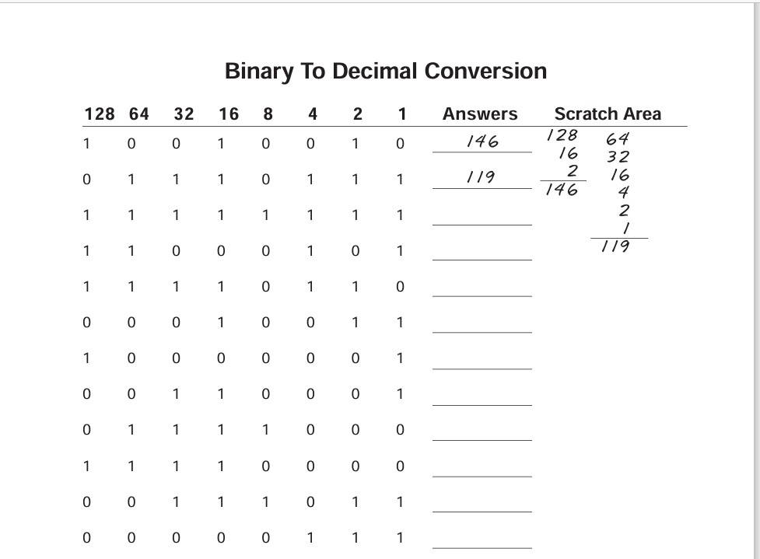

**Answer**

1. 146
2. 119
3. 255
4. 197
5. 246
6. 19
7. 129
8. 49
9. 120
10. 240
11. 59
12. 7

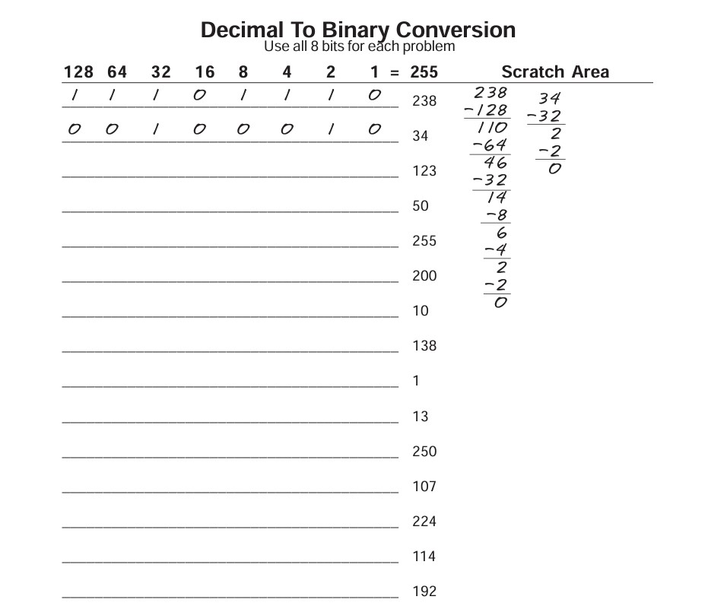

**Answer**

1. 1 1 1 0 1 1 1 0
2. 0 0 1 0 0 0 1 0
3. 0 1 1 1 1 0 1 1
4. 0 0 1 1 0 0 1 0
5. 1 1 1 1 1 1 1 1
6. 1 1 0 0 1 0 0 0
7. 0 0 0 0 1 0 1 0
8. 1 0 0 0 1 0 1 0
9. 0 0 0 0 0 0 0 1
10. 0 0 0 0 1 1 0 1
11. 1 1 1 1 1 0 1 0
12. 0 1 1 0 1 0 1 1
13. 1 1 1 0 0 0 0 0
14. 0 1 1 1 0 0 1 0
15. 1 1 0 0 0 0 0 0

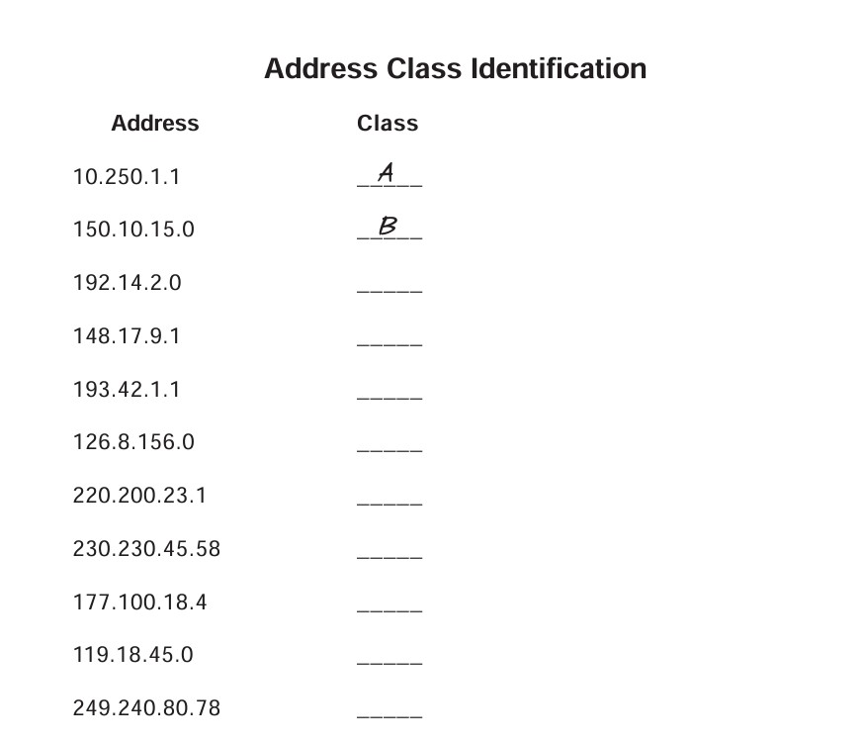

**Answer**

1. Class A
2. Class B
3. Class C
4. Class B
5. Class C
6. Class A
7. Class C
8. Class D
9. Class B
10. Class A
11. Class E

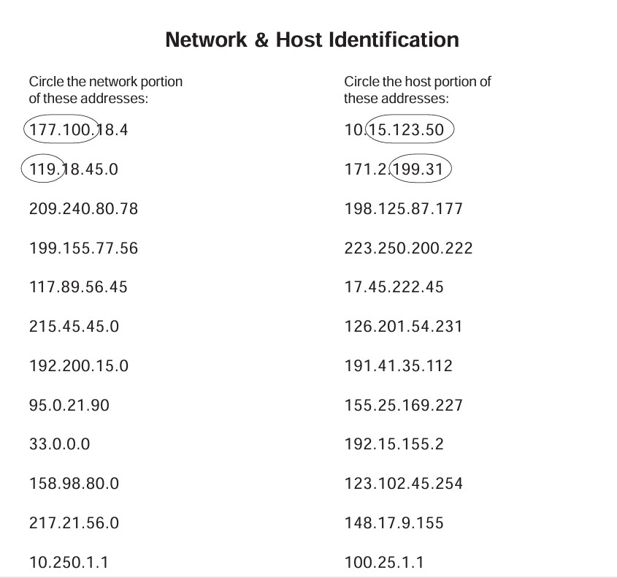

**Network And Host Identification**

**A) Circle the Network**

3) 209.240.80.78 – 209

4) 199.155.77.56 - 199

5) 215.45.45.0 - 215

6) 192.200.15.0 - 192.200

7) 95.0.21.90 - 95

8) 33.0.0.0 - 33

9) 158.98.80.0 - 158.98

10) 217.21.56.0 - 217.21.56

11) 10.250.1.1 - 10

**B) Circle the Host portion**

3) 198.125.87.177 - 177

4) 223.250.200.222 - 222

6) 17.45.222.45 - 45.222.45

7) 126.201.54.231 - 201.54.231

8) 191.41.35.112 - 35.112

9) 155.25.169.227- 169.227

10) 192.15.155.2 - 2

11) 123.102.45.254 - 102.45.254

12) 148.17.9.155 - 9.155

13) 100.25.1.1 - 25.1.1

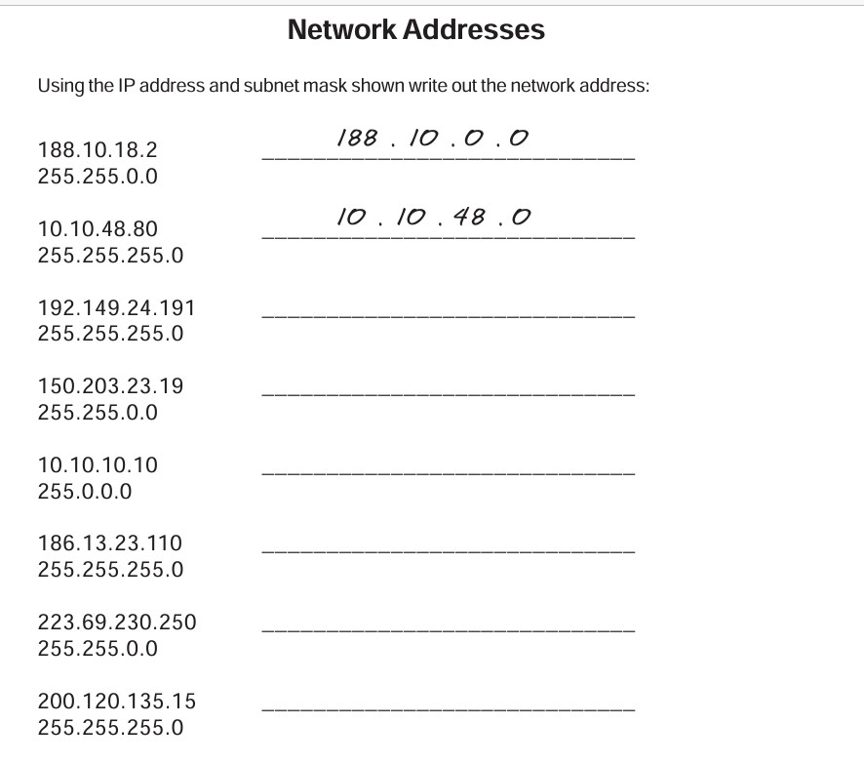

**Answer**

3) 192.149.24.191

255.255.255.0 -- 192.149.24.0

4) 150.203.23.19

255.255.0.0 -- 150.203.0.0

5) 10.10.10.10

255.0.0.0 -- 10.0.0.0

6) 186.13.23.110

255.255.255.0 -- 186.13.23.0

7) 223.69.230.250

255.255.0.0 -- 223.69.0.0

8) 200.120.135.15

255.255.255.0 -- 200.120.135.0

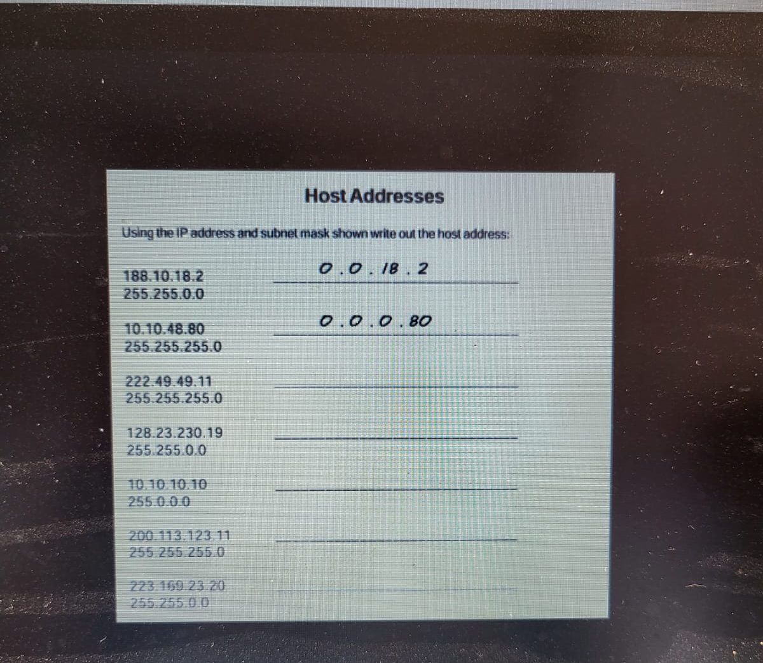

**Answer**

3) 0.0.0.11

4) 0.0.230.19

5) 0.10.10.10

6) 0.0.0.11

7) 0.0.23.20

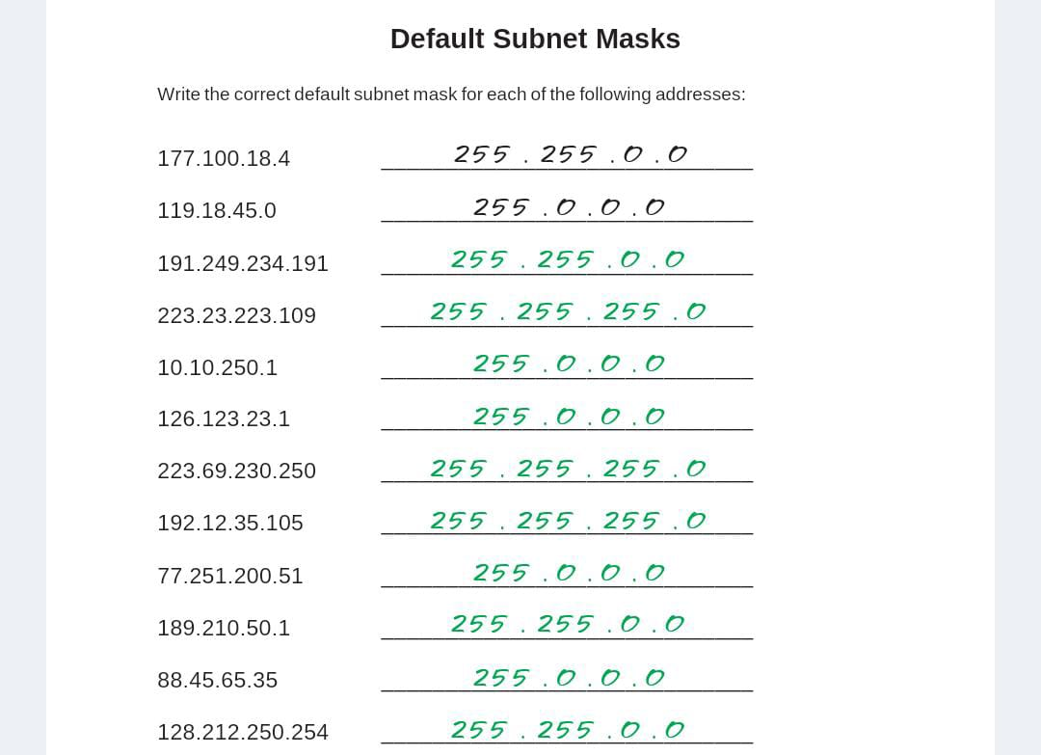

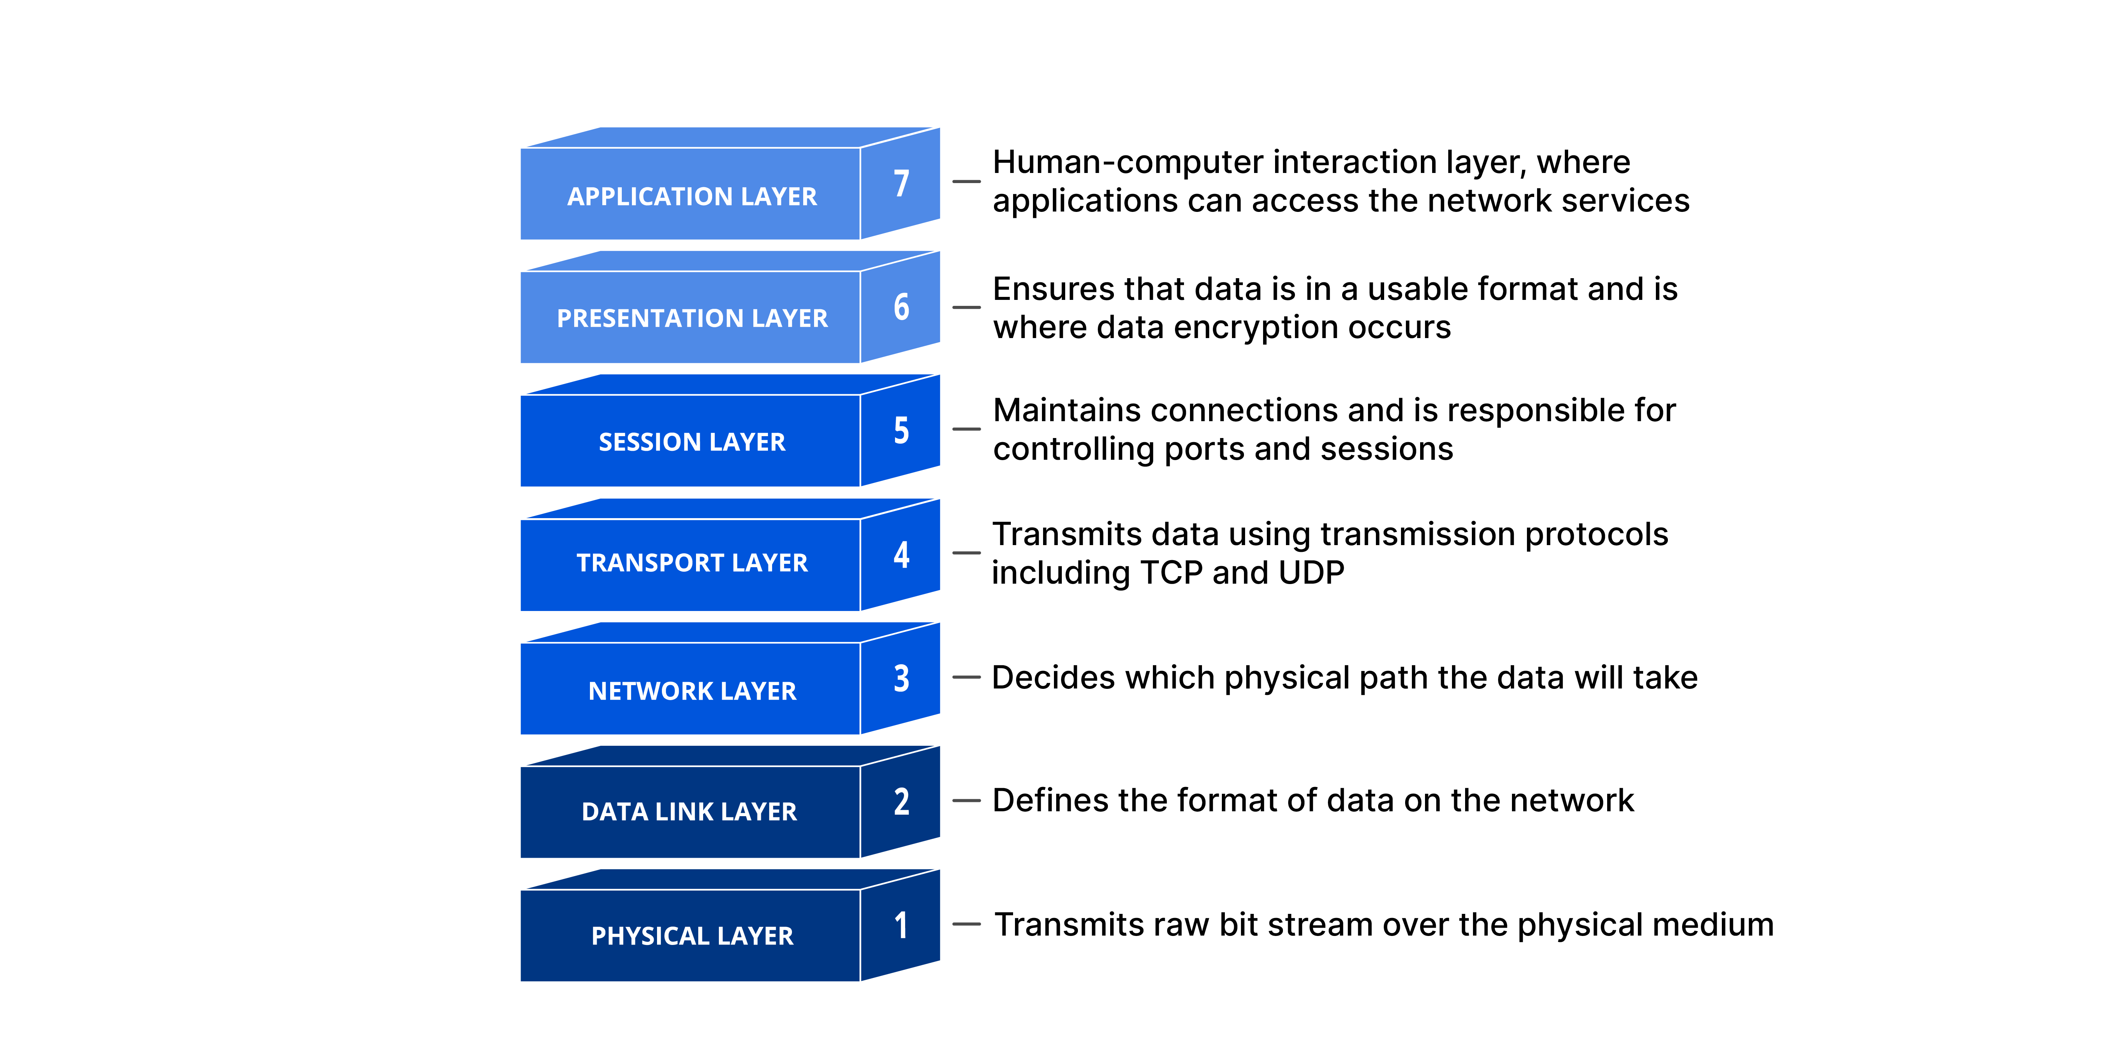

**OSI Model**

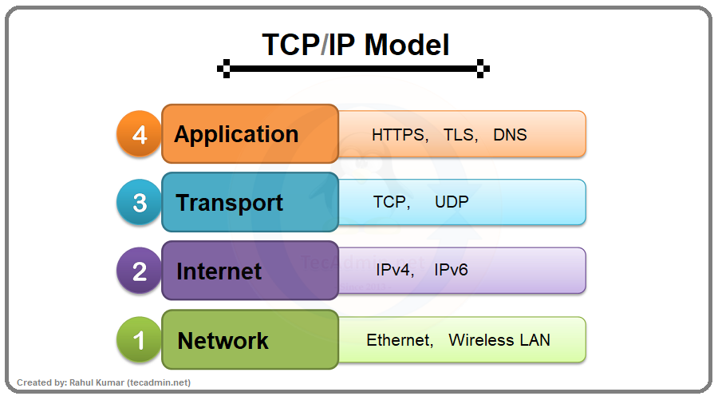

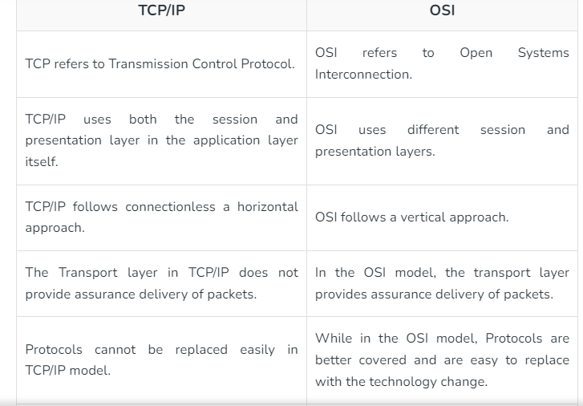

**Diffrence b/w Tcp/Ip and Osi model**

**What are the services of layer 7 in Osi model ?**

Layer 7 is known as Application layer. It serves as the interface for commnication between users and the network. It provides application specific services like HTTP requests,File Transfer , Email and Web browsing.

**What are the port numbers of layer 7 services ?**

1. HTTP – Port 80
2. HTTPS – Port 443
3. FTP – Port 21
4. SMTP – Port 25
5. IMAP – Port 143
6. DNS – Port 53
7. SSH – port 22
8. RDP – Port 3389
9. IRC - Port 194

**Sending email, which service of layer 7 is used?**

It uses SMTP. (Simple Mail Transfer Protocol)

**Taking remote access , which service of layer 7 is needed?**

It uses SSH.(Secure Shell) and another common service for remote access is RDP(Remote Desktop Protocol) , which is specially used in windows environment.

**Lab Work (Day 1)**

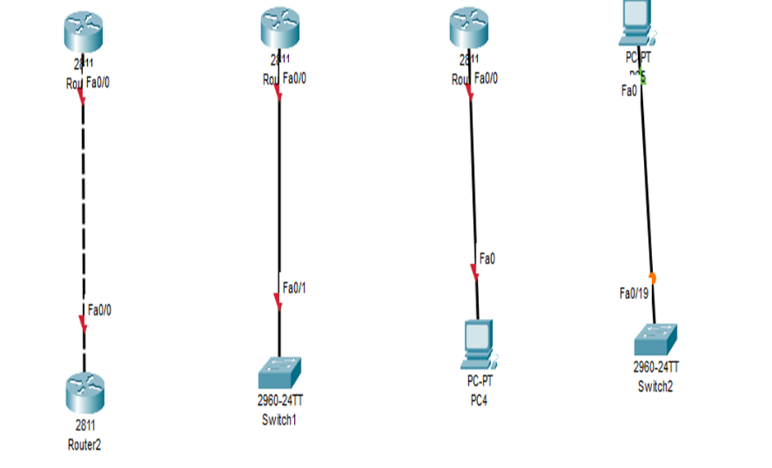

Connect two routers

Connect Router with a Switch

Connect Router with PC

Connect PC with a switch

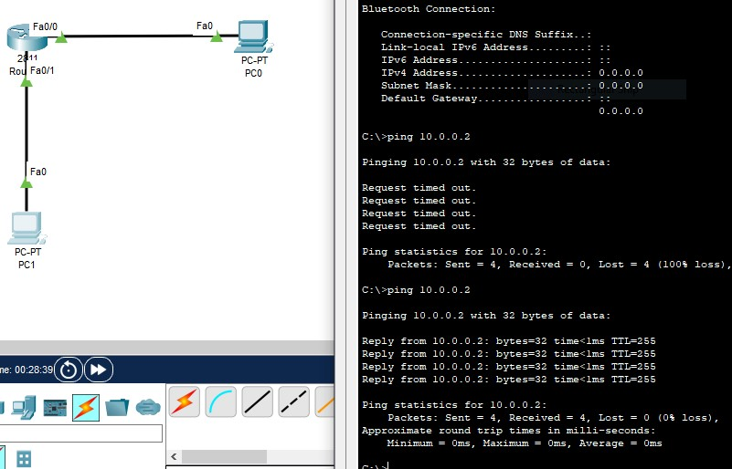

Connection between Router and two Pc assigning ip address.

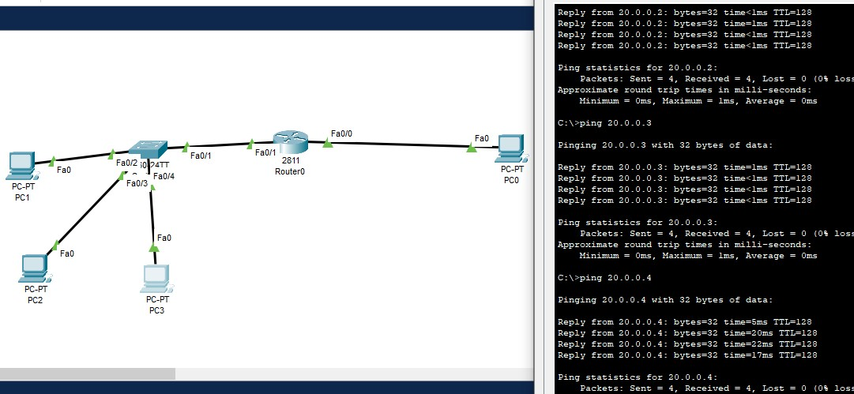

**Router connection using switch and show the ping status of pc.**

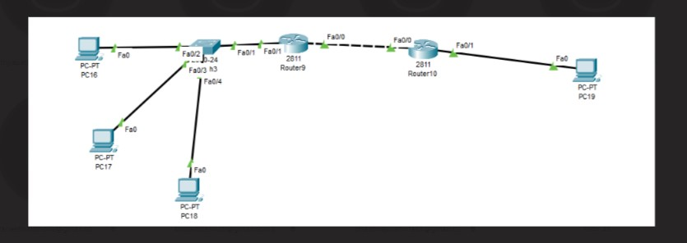

**Connection using switch and multiple routers.**

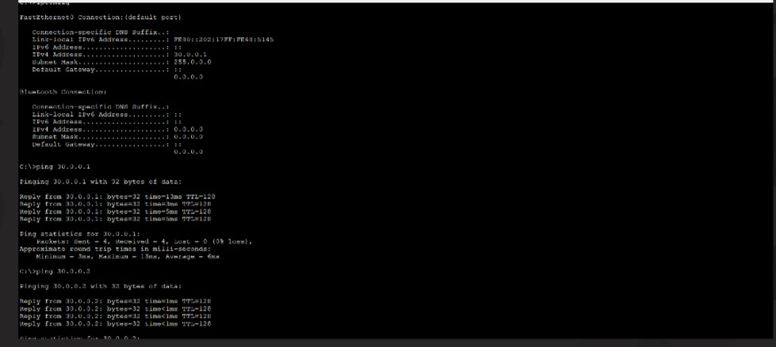

**Ping Status of the previous connection.**

**Lab Work (Day 2)**

|  |  |  |  |  |
| --- | --- | --- | --- | --- |
| Connection | R1- F0/0 | R1 – F0/1 | R2 – F0/0 | R2 – F0/1 |
| PC 1 | Connected | Connected | Not Conected | Not Connected |
| PC2 | Not Connected | Not Connected | Connected | Connected |

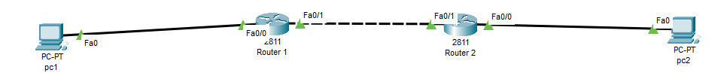

**Ip address connection table**

**Static Routing Parts :**

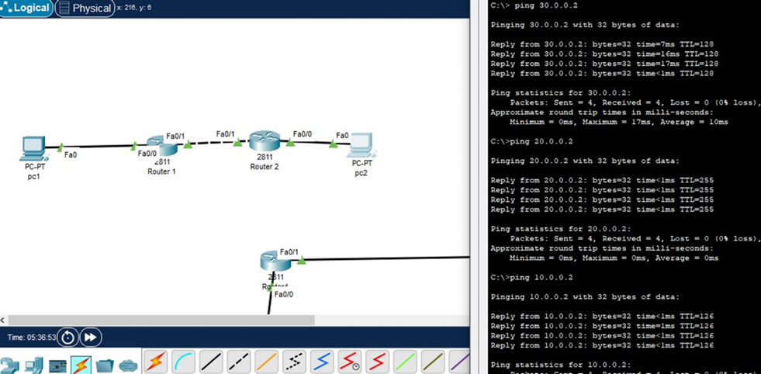

**Routing and Checking ping status.**

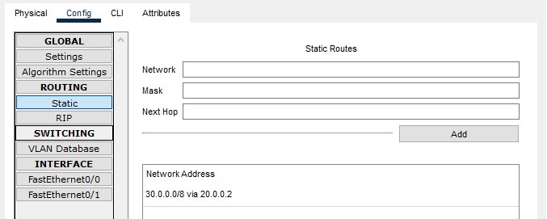

**Connection Network Address(30.0.0.0/8 via 20.0.0.2)**

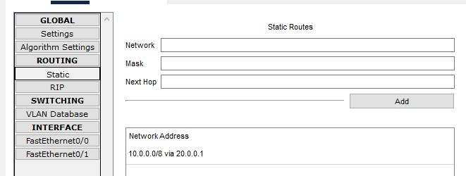

**Connection Network Address(10.0.0.0/8 via 20.0.0.1)**

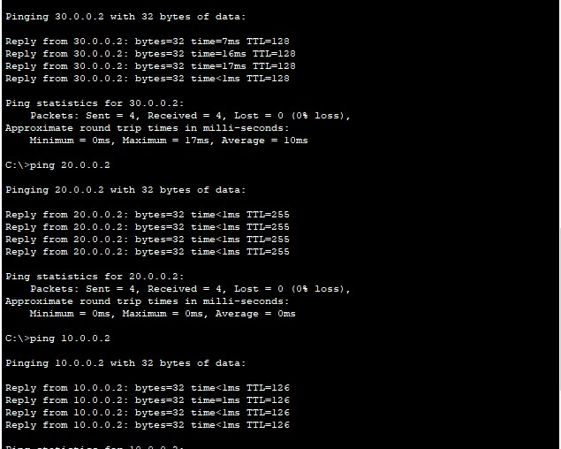

**Pc1 And Pc2 Pinging With Eachother**

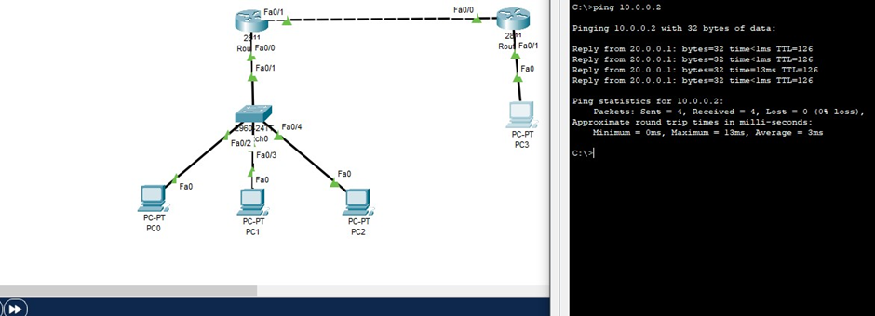

**Ip Natting**